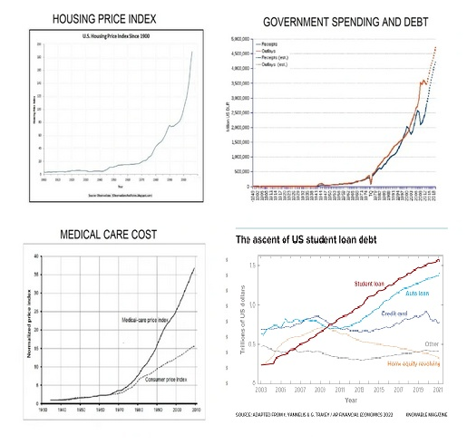

(9, 10)

Inflation is mainly the result of the expansion of currency in circulation in excess of demand. This is what inflation looks like. Housing cost, Government Spending, Medical Care Cost, and Student Loan Debt, all rising exponentially. This cannot continue without eventual economic disaster.

The biggest money maker for the super-rich manipulators is the Federal Reserve and central banks in every other country. Inflation of only 3% per year is 30% every 10 years!

Government borrowing from the FED and spending is the main source of economic enslavement and is beyond comprehension and belief.

A billion seconds ago it was 1959.
A billion minutes ago Jesus was alive.
A billion hours ago our ancestors were living in the Stone Age.
A billion dollars ago was only 8 hours and 20 minutes, at the rate Washington spends it.

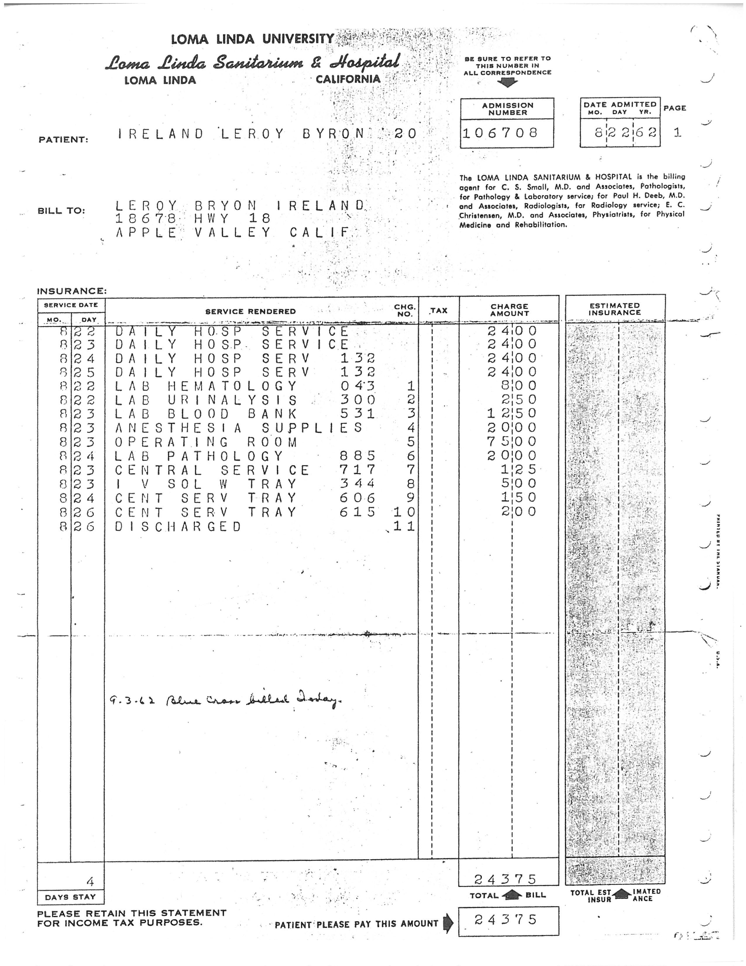

MEDICAL CARE COST CRISIS
Medical care cost, which has outpaced inflation by more than double, is especially insidious. People die and/or go bankrupt as a result. This is due to the over-regulation of medical care industry and insurance companies in particular.(20) My dad had major cancer surgery in 1962 requiring 4 days at Loma Linda University Medical Center and the total billed to Blue Cross was $243.75. At $24 per day room rate and $60 per day for the total service, health care was once affordable. Adjusting for inflation, the present room rate should be about $240 per day and total service about $600 per day. The FDA drives up the prices by 1) delaying the introduction of life-saving therapies, 2) suppressing safe methods of preventing disease, causing the price of drugs to be so high that some do without, 4) denying access to effective drugs approved in other countries, 5) intimidating those who develop innovative methods to treat disease, 6) approving lethal prescription drugs that kill, 7) censoring medical information that would let consumers protect their own health, 8) censoring medical information that would better educate doctors, 9) misleading the public about scientific methods to increase longevity, and 10) failing to protect the safety of our food. For an example of this, Monsanto genetically engineered BT Toxin into corn without any FDA approval required. (21, 26, 27)

HERE IS THE MOST SIGNIFICANT FACTOR with regard to medical care cost. Insurance company profits are regulated by an insurance commissioner in every state plus federal laws to a maximum of about 10%. With that restriction, if the profit is at its maximum, profit can only be increased if expenses could somehow be increased which would justify increasing premiums and 10% of those increased premiums would be an increased profit. Insurance companies simply enabled medical care cost and malpractice claims to increase. (22) This perverted profit motive has been in operation for over 50 years and has greatly increased profit. Now the hospital bill for one night can cost over $10,000. Why else would any insurance company agree to pay that much?
Insurance companies, if deregulated and allowed to increase their profit by decreasing expenses, could offer free market services that government now provides. If they provide product liability insurance for a drug company, they could establish an organization that would set reasonable testing standards and oversee and approve the results. The emphasis would be on he best solution not the most expensive.
On the street where I do my workout, I met Rita, a nurse who impressed me with her knowledge of Quercetin, Ivermectin, and Zinc for preventing and treating Covid-19. I told her about BHT (32) and she told me about Bangladesh. She met a doctor from Bangladesh that told her about the low number of deaths in his country from Covid-19 because Ivermectin is widely used there. I looked up the statistics in February 2021 and the deaths per capita in the US was 30 times higher than in Bangladesh. (53) Bangladesh, with half the population of the US, had 8,400 casualties, the US 500,000!
Why would health agencies completely ignore this information? The earliest report on the effectiveness of Ivermectin that I could find was at msn.com on May 19, 2020. (54) Youtube removed Dr. Pierre Kory's Senate testimony about the success of Ivermectin February 9, 2021. (56) Why would the media censor this information? An NIH update on February 11, 2021, reported, “Ivermectin is not approved by the FDA for the treatment of any viral infection.”(58) However, a WHO-sponsored review of Ivermectin trials published December 31, 2020, indicates an 83% reduction in Covid mortality.(57) The FDA and NIH with the cooperation of the media are guilty of large scale death and destruction of the economy for the purpose of maximizing drug company profits from immunizations (and also getting rid of Trump).

A defective study was done early on that concluded that Hydroxychloroquine was ineffective and potentially dangerous. It was a lie, the opposite is true. (50) Two studies on Ivermectin just started Feb 27, 2021 in the United States. Why so late? Why wait 9 months? (55) Why do studies from other countries not count, even during a pandemic?
Favipiravir (46), Hydroxychloroquine (45), and especially Ivermectin (over 90% effective with Doxycycline) (44), have been proven safe and effective especially when given with vitamin D3, C, Quercitin, Melatonin, and Zinc. (44 page 9) They are a broad spectrum inexpensive solutions to prevent Coronavirus infections unlike vaccines which are expensive and target a narrow genetic code spectrum. As the virus mutates eventually a new vaccine will be required, likely every year, just like the regular flu shot, making millions of dollars for the drug companies.
Hydroxychloroquine is an antimalarial drug and Ivermectin is an anti-parasitic drug. I have wondered what they have to do with viruses. They both improve the effectiveness of Zinc and Zinc is toxic to both parasites and viruses. (48)
Presisdent Trump was taking Hydroxychloroquine but got Covid-19 in October 2020. Why? Because he quit taking it in May. He caved to the hype that concluded that there was no benefit and it may cause more harm than good. In those studies Hydroxychloroquine was given after a Covid infection had progressed and the patients were in ICU. (49) It is much more effective when given earlier. (45)
Since the FDA has made the above three all but impossible to acquire, here is an alternative. Dr. Kelly Victory claimed that Hydroxychloroquine and Ivermectin have a beneficial effect on Zinc and that is why, when taken together, they prevent one from getting Coronavirus. She said that Quercetin also has a beneficial effect on Zinc and could be just as effective in preventing Coronavirus infections.
Also BHT has clinically been studied and found effective against lipid coated viruses as reported at nih.gov in 1985! It has been documented to cure shingles, genital herpes, epstein barr, and many other viruses. (32) Coronavirus is a lipid coated virus yet BHT has never been considered for study. Why? The fact that it is available and cheap could have everything to do with that.
I have been taking BHT as a supplement for over 30 years as recommended by the book, “Life Extension: A Practical Scientific Approach” by Durk Pearson and Sandy Shaw. I know that it is safe.
For Covid prevention I recommend, in order of importance: (Minimum mg per day) (47)
Ivermectin (if you can get it) an oral monthly dose of 12mg for 4 months.(59)
BHT 500mg
Quercetin 250 mg
Zinc 30–50 mg
Vitamin C 1000 mg
Vitamin D3 1000 IU summer, 3000 IUwinter (51)
Melatonin 2 mg at night
Vitamin K2 75 to 125 micrograms
Magnesium Glycinate 300 mg
B Complex Vitamins 2 times Recommended Daily Allowance The FDA testing requirements add millions of dollars to the cost of drug approval making cheap and available solutions unprofitable. Only patentable profitable drugs are considered. The FDA policies maximize drug companies profits.

Also, consider this, since placebo effect has been proven safe and effective, why eliminate it as a factor in clinical studies? When a doctor prescribes a drug, the patient will naturally have a belief that it will work. Placebo effect is a factor in the real life application of drug therapy anyway.

But even with very serious diseases, the FDA requires giving one group the drug and the other group doesn't get the drug and the data of how many in each group die determines the effectiveness of the drug. That is just immoral and disgusting. It would be better to have two or more drugs with potential to be given to different groups and compare the results. At least everyone would have a better chance of survival. If only one drug is available, then give it to everyone and compare the data before the drug was available with the data after.
REAL ESTATE PRICE INFLATION (8) YEAR APPRAISED VALUE MONTHLY RENT YEARLY SALARY 1975 $34,000 $100 $17,000 2019 $600,000 $2,000 NOT $300,000
PROFIT: $566,000 In the mid 1970s I purchased my first house in Los Angeles for $34,000. The payment was less than $200 per month, a big step from the $100 per month I paid for renting a house. I made $17,000 per year at that time as an engineering lab supervisor. That same house today in 2019 would rent for at least $2,000 per month and be valued at over $600,000 but my income is not anywhere near $300,000 per year. That is what I would be making if wages kept up with the cost of housing. If I still owned that house and sold it today, the $566,000 profit would come from younger generations having to accept a lower standard of living. The profit comes from our children. Bureaucratic over-regulation, fees, and permits can add over $100,000 to the cost of a house before construction starts.(19) The property tax alone in California would add about $600 per month to the mortgage payment and continues even after the mortgage is paid off. It is, in effect, a rent payment that increases every year. Real estate is the only property that you can never actually own.

PERCENTAGE OF LAND AREA OWNED BY THE FED

Adding to the cost of real-estate is the artificial shortage of land. The federal government claims 58% of the land west of the Mississippi River.(18)
When I was young, in the 60's, I assumed that I would eventually buy a house. Young people now question if they will ever be able to afford the rent let alone buy a house. This is an unnatural decline after over 200 years of economic progress and technological advancement.
Inflation is the result of an unethical banking system. The Federal Reserve is able to create money out of nothing and lend the currency into circulation through various means at a huge profit. This is the original cyber currency. If the central bank increases the money supply by One Trillion Dollars, usually by financing government debt, that money is spent and as it works its way through the banking system, the banks can use 10% of that as reserves and lend another One Trillion Dollars also at a huge profit. The bottom line, if a banking system profits from inflation, it will generate constant inflation.
It used to be that if one wanted to borrow money, the lender would have to find people that had accumulated extra money that they were willing to lend. The interest rate paid to them and the interest rate of the loan were subject to the balance of supply and demand.
The present system, however, offers an unlimited supply of money to lend at arbitrarily low interest rates. With an unlimited supply of cheap money, saving is punished and borrowing is usually the only choice for big ticket items, especially real estate. With fewer and fewer middle income people able to qualify for the loan on a house, the rich can still buy the house, charge rent, and make money on inflation. With this process, the rich get richer and accumulate more and more property and at the same time the middle and lower class suffer with the higher cost of housing.
The same effect of inflation is true for commercial and industrial property. Few business owners can afford to purchase the property where their business is located. The vast majority pay rent and the rent goes up every year and never goes down, not even during the Great Recession. That cost is past on to their customers adding to inflation.

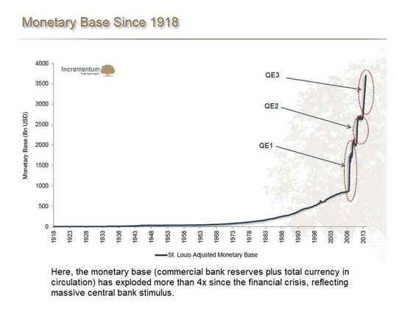

(12)

The reason why interest rates are so low is because of the Federal Reserve's Quantitative Easing programs. Because the Great Recession almost destroyed the economy, something dramatic had to be done. By increasing bank reserves, banks have much more lending capacity than the demand for loans. Interest rates are lowered in order to increase the demand for loans. A simple case of supply and demand.
The typical bureaucratic solutions like minimum wage, rent controls, price controls, welfare, medicare, and Social Security programs do nothing to solve the problem.
Borrowing money and raising taxes to finance entitlements to buy votes causes more inflation which makes people worse off and they feel they deserve more entitlements. It is a vicious cycle.
The major problem with inflation is the inability to save for retirement. When I first started working in the early 70s I made less than $3 per hour. Money saved then would not contribute significantly to my retirement now. The Social Security system now requires present taxes on people working to pay benefits for the retired. That Ponzi Scheme is yet another burden on younger generations.
It used to be that adults would take care of their parents. In fact the need for eldercare is increasing. But with the economic enslavement, this has become more and more difficult placing an additional burden on younger generations. (29)
However, that presents yet another problem because of the baby boom demographic. When I was young, there were about 10 people working for every one retired. When all of the baby boomers retire, the ratio is predicted to be 2 to 1. How can that possibly work? Higher taxes and higher government debt of course.

Or plan B, cause a Great Recession that destroys retirement accounts and reduces home equity to the point of massive foreclosures and bankruptcies. The Great Recession was designed and implemented by the establishment, especially the Federal Reserve. They took the Great Depression as a template and substituted a real estate boom for a stock market boom. The law was changed to allow banks to make risky investments and then banks were required to make subprime loans or risk being charged with discrimination at a federal level. The real estate boom was huge. There is a fundamental principle of intentional boom and bust cycles and that is, the bigger the boom, the bigger the bust. (28)
The establishment took an extreme measure to save Social Security from bankruptcy. According to the Bureau of Labor Statistics, among 65- to 74-year-olds, labor force participation is predicted to hit 32 percent by 2022, up from 20 percent in 2002. At age 75 and up, the rate will jump from 5 percent in 2002 to 11 percent in 2022. If enough people can't afford to retire then the problem is solved. (13)

